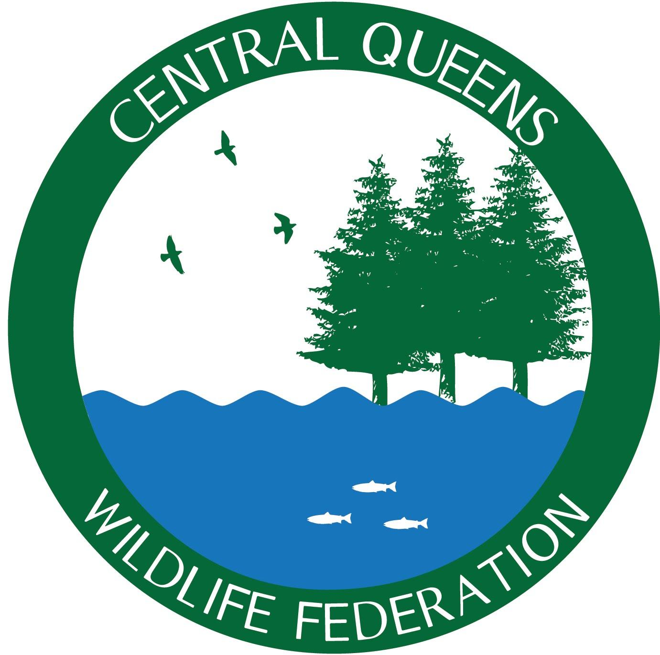
Central Queens Branch of the PEI Wildlife Federation WATERSHED NEWS
Spring 2024
To start our 2024 season we want to share some of the major projects we will be starting or continuing from last year's field work. We are going to start publishing two newsletters a season, one for recapping our field work and another for stating our goals for the year.

Summer Field Season Plans
Our watershed like many others were badly affected by Hurricane Fiona, which increased the amount of blockages within our streams. During our 2023 season we worked hard on clearing these blockages and will continue to work at this hurdle in 2024. CQWF received funding support from the PEI Wildlife Conservation Fund for our Hurricane Fiona remediation activities, which will help us during our restoration work this 2024 field season. Our crew will work hard to clear previous sections of stream, as well as possibly clearing new stream sections within our watershed. Once sections of stream are cleared our crew will install new brush mats, and cover structures to areas in need. Another major project we are undergoing this year is rebuilding two deflector structures by Black Brook on the main West River and this project is also funded by the PEI Wildlife Conservation Fund. The current deflectors are deteriorating due to them being built in the early 2000’s.
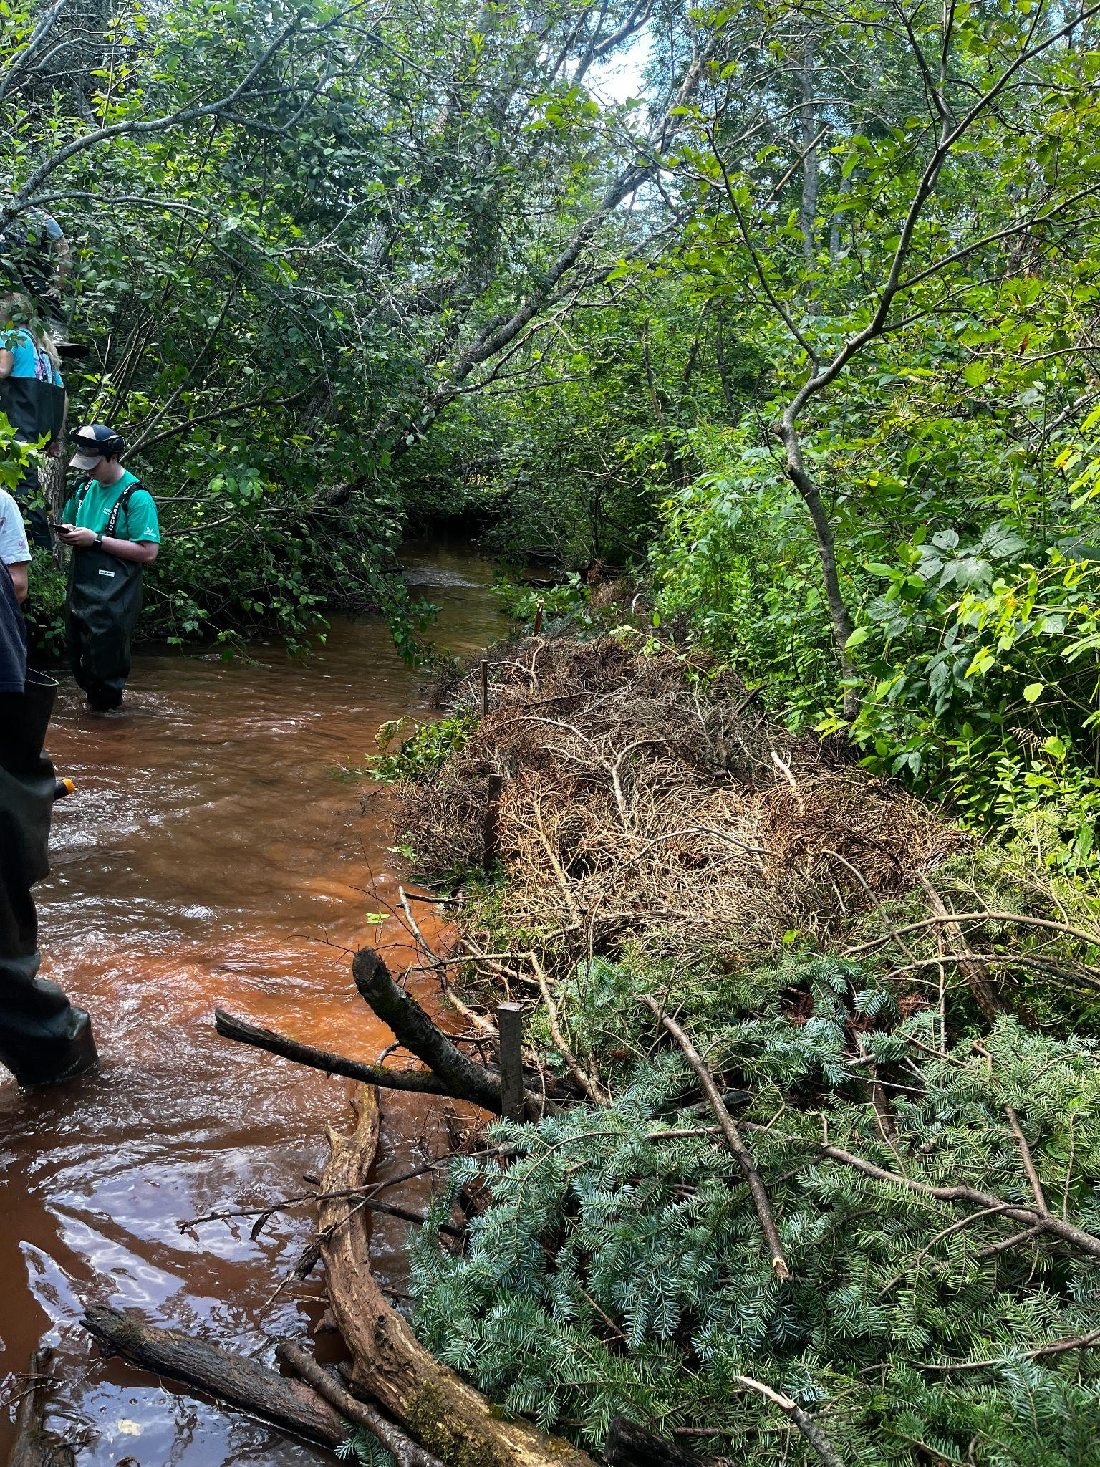
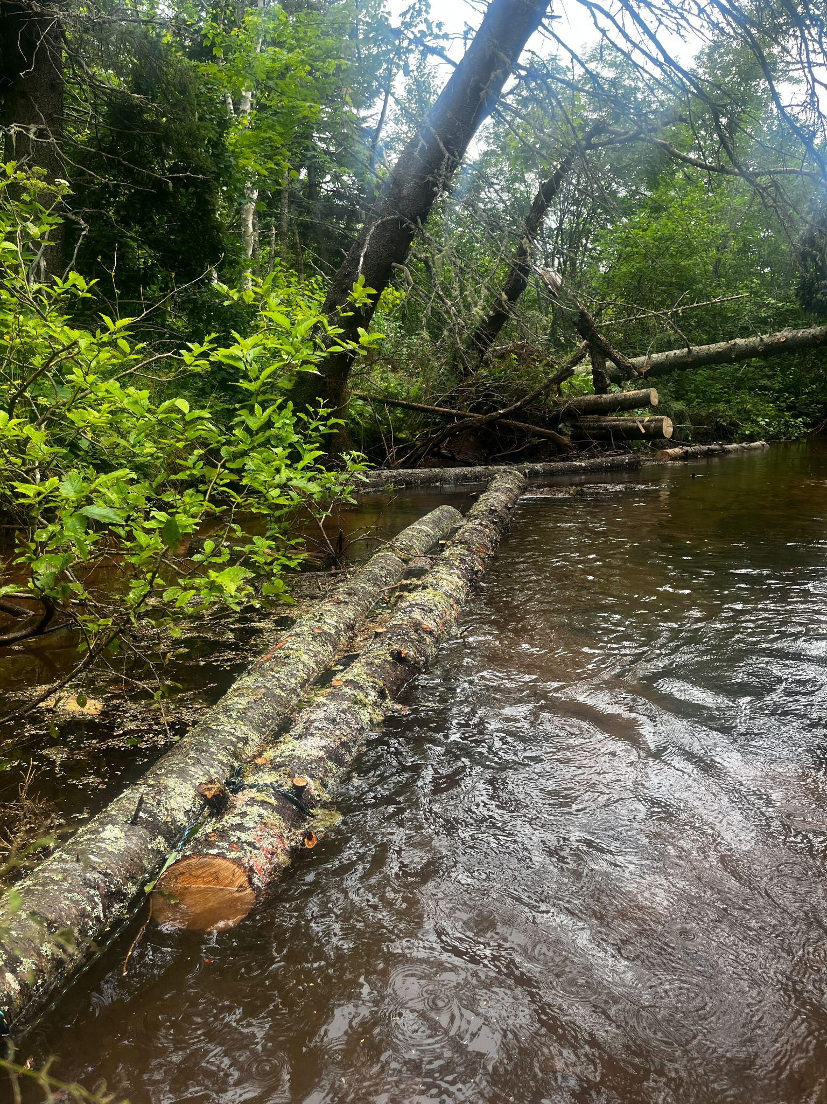

Cover Structures and Brushmat on Howell’s Brook

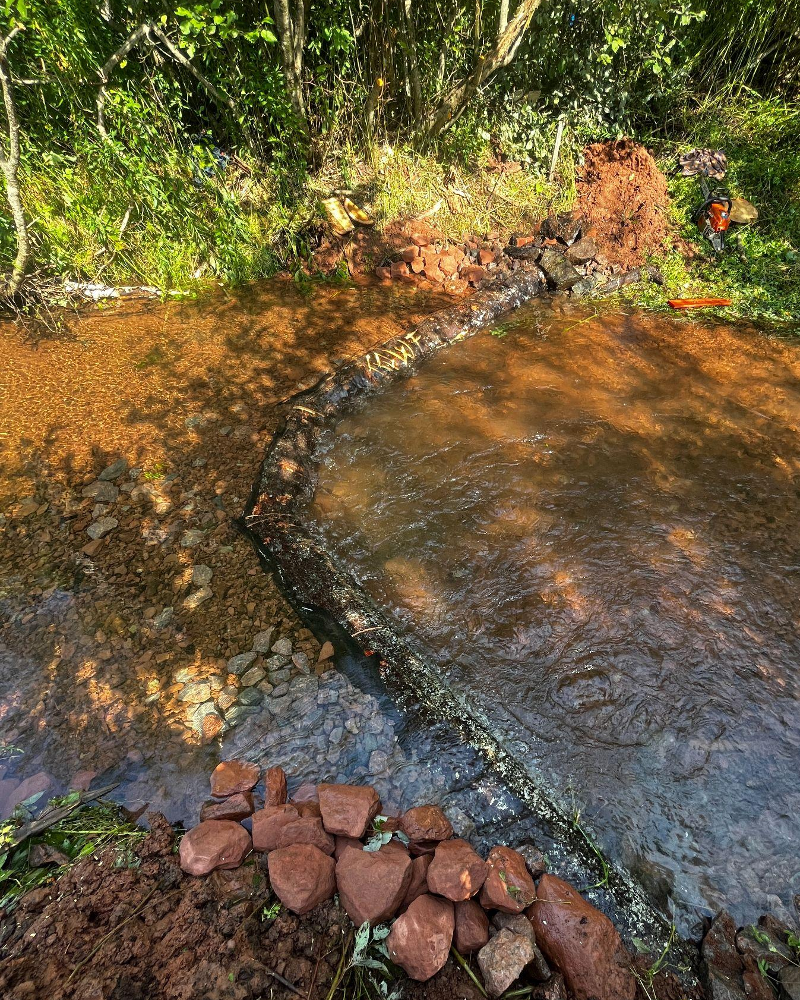
Salmon Habitat Upcoming Plans
Soft engineered structures will be created in Brookvale in 2024 along sections of river lacking high quality spawning habitat. These structures can help to increase embryo survival and ultimately juvenile recruitment by providing high quality spawning habitat.
Gathering information about Atlantic salmon helps educate our science based decisions to apply the best management practices. Our crew plans to continue to work on technical reports such as the spawning habitat characterization report. We hope that other watershed crews focused on salmon habitat rehabilitation can use these resources.
Vortex digger log on Howell’s Brook

Redd surveys are annually conducted during the fall work season, performing these surveys is crucial to compare with historical data, help identify population trends estimates, and identify spawning habitat.

Support for our Atlantic salmon restoration work this season was graciously supported by The Foundation for Conservation of Atlantic Salmon. This organization provides funding to support our spawning habitat activities and other monitoring ventures.

Other Restoration and Monitoring Topics
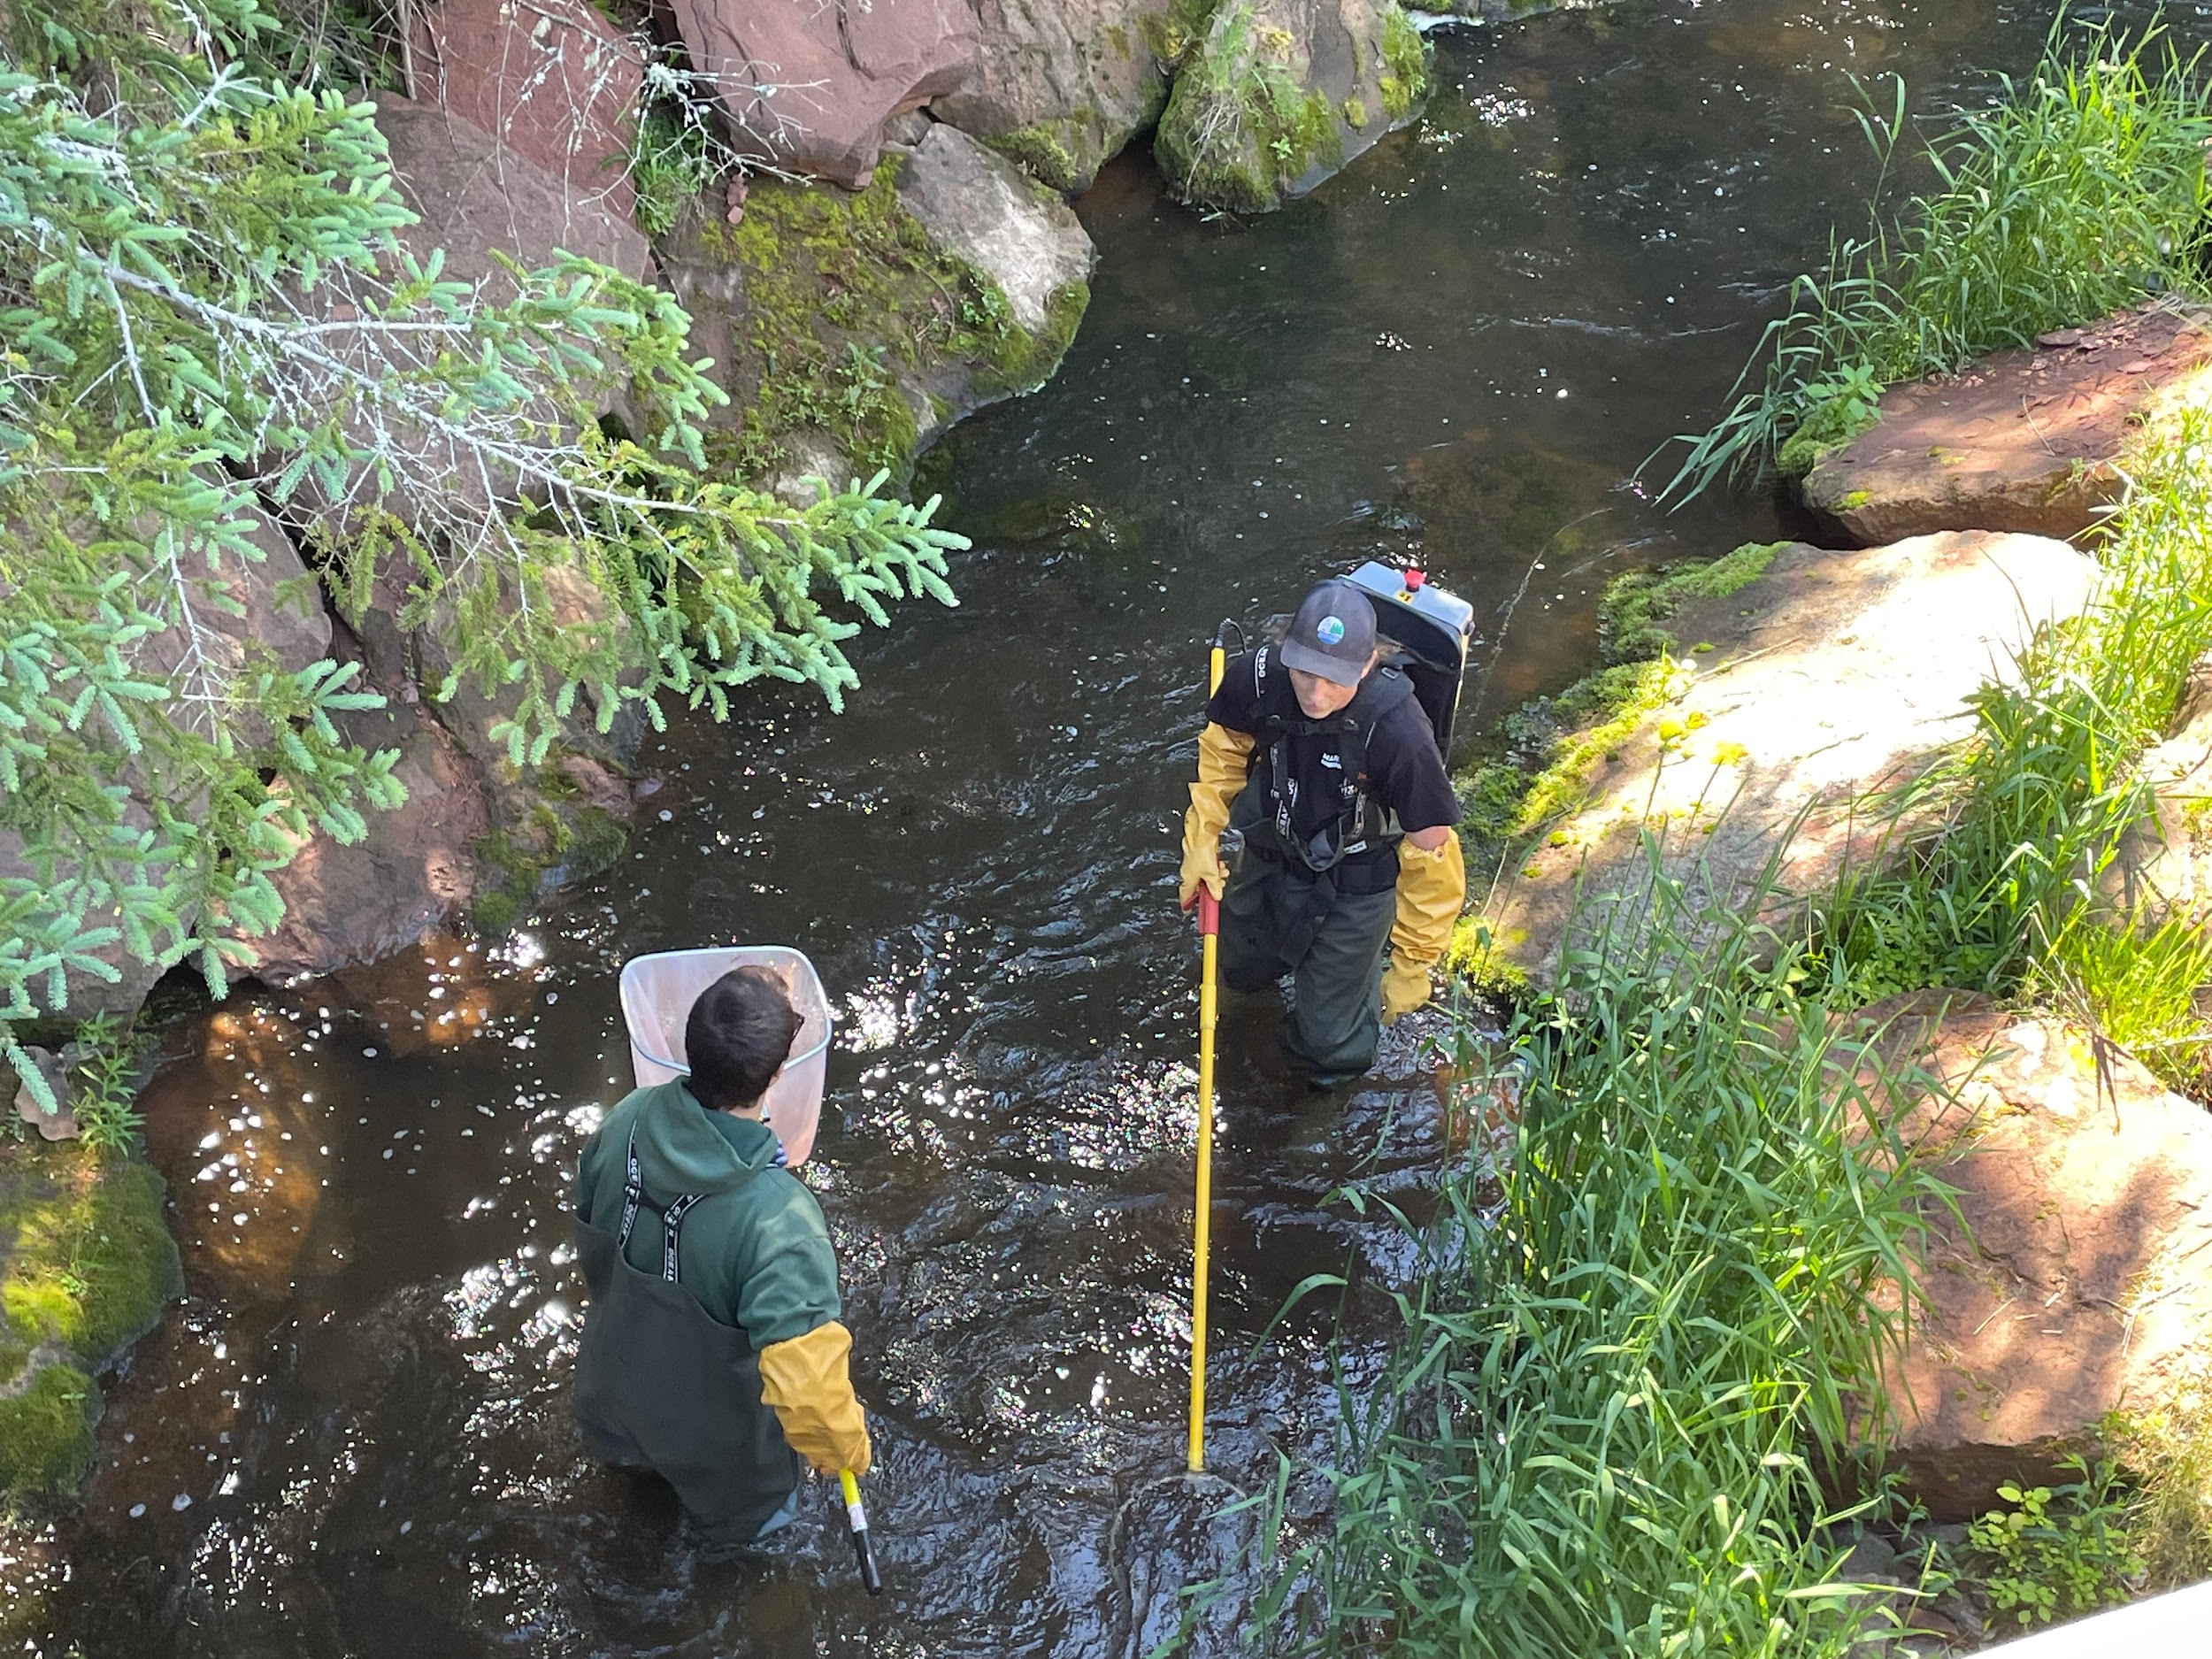
Our riparian habitat enhancement activities involve planting native trees and shrubs. Many of these planting locations were focused on areas damaged by Hurricane Fiona. These patch cuts were planted with suitable species such as red oak, white ash, yellow birch, eastern hemlock and fruit bearing shrubs for wildlife. Species are carefully selected and planted in suitable habitat to help produce more resilient forests, increase biodiversity, and ultimately work towards restoring our native Acadian forest composition. This aspect of our work wouldn't be possible without the help from the Provincial Frank Gaudet Tree Nursery who grows and nurtures the trees we use to plant.
There are several monitoring activities that CQWF conducts on an annual basis in order to monitor important environmental indicators. This information is incorporated into our management based decisions, and management plans. This includes water quality monitoring (19 sites biannually), juvenile salmonid density surveys (14 electrofishing index sites). Technical reports can be found on CQWF’s website under the Management Plans and Technical Reports tab.
CQWF crew catching fish during electrofishing surveys

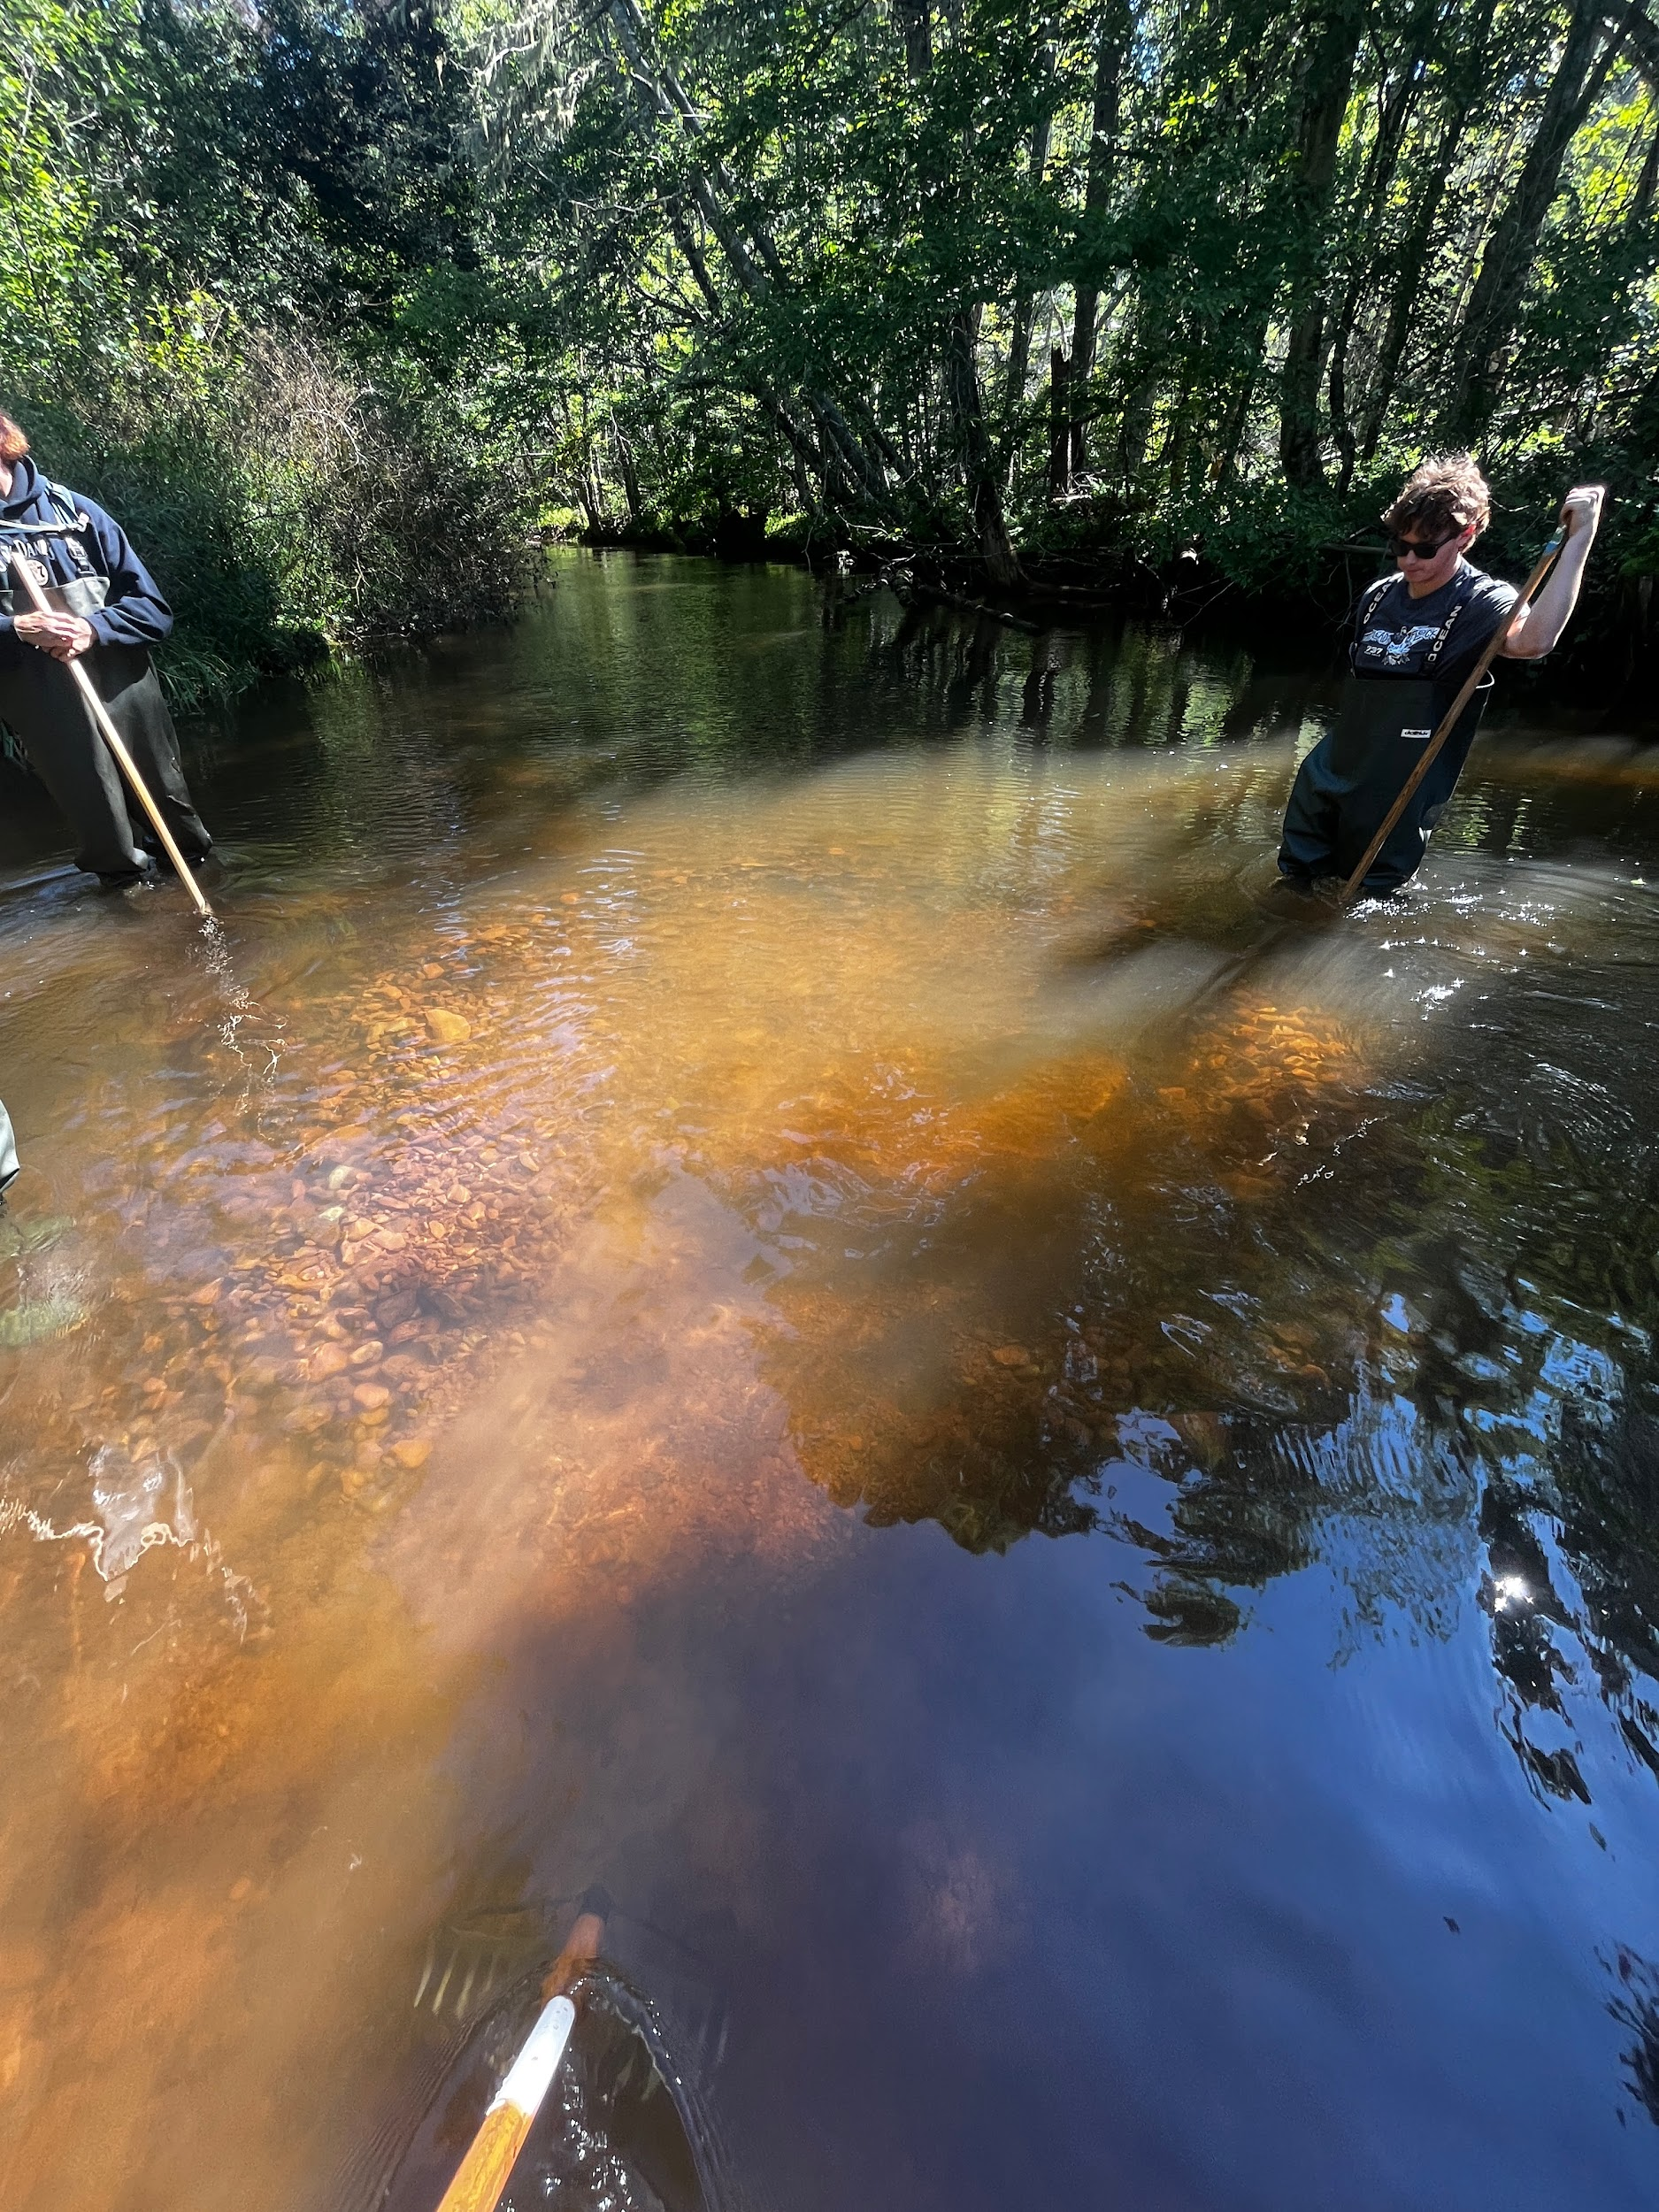
New CQWF Project Coordinators this year!
For the past 7 years Jordan Condon has been the coordinator for CQWF. Jordan started as a crew member in 2012 and quickly fell in love with the watershed life. Jordan has done an amazing job creating new management plans, guiding new crew members throughout the years, and his work and passion in the position will not go unnoticed. Jordan will stay involved in the conservation field taking on the science coordinator position with the ASF in the Wild Salmon Watersheds program. Starting this 2024 spring field season we will have a co-coordinator position. Isaac Arsenault-Saunders and Knowlton Parkman have been on the field crew of CQWF for several years, and are excited to step up and fill Jordan's role as Project Coordinator. These individuals are very eager to get started and make an environmental difference with CQWF. If you have any concerns or ideas for our new coordinators feel free to reach out to cqwf.pei@gmail.com.
CQWF crew loosening substrate of a previous Salmon redd

Get Involved!
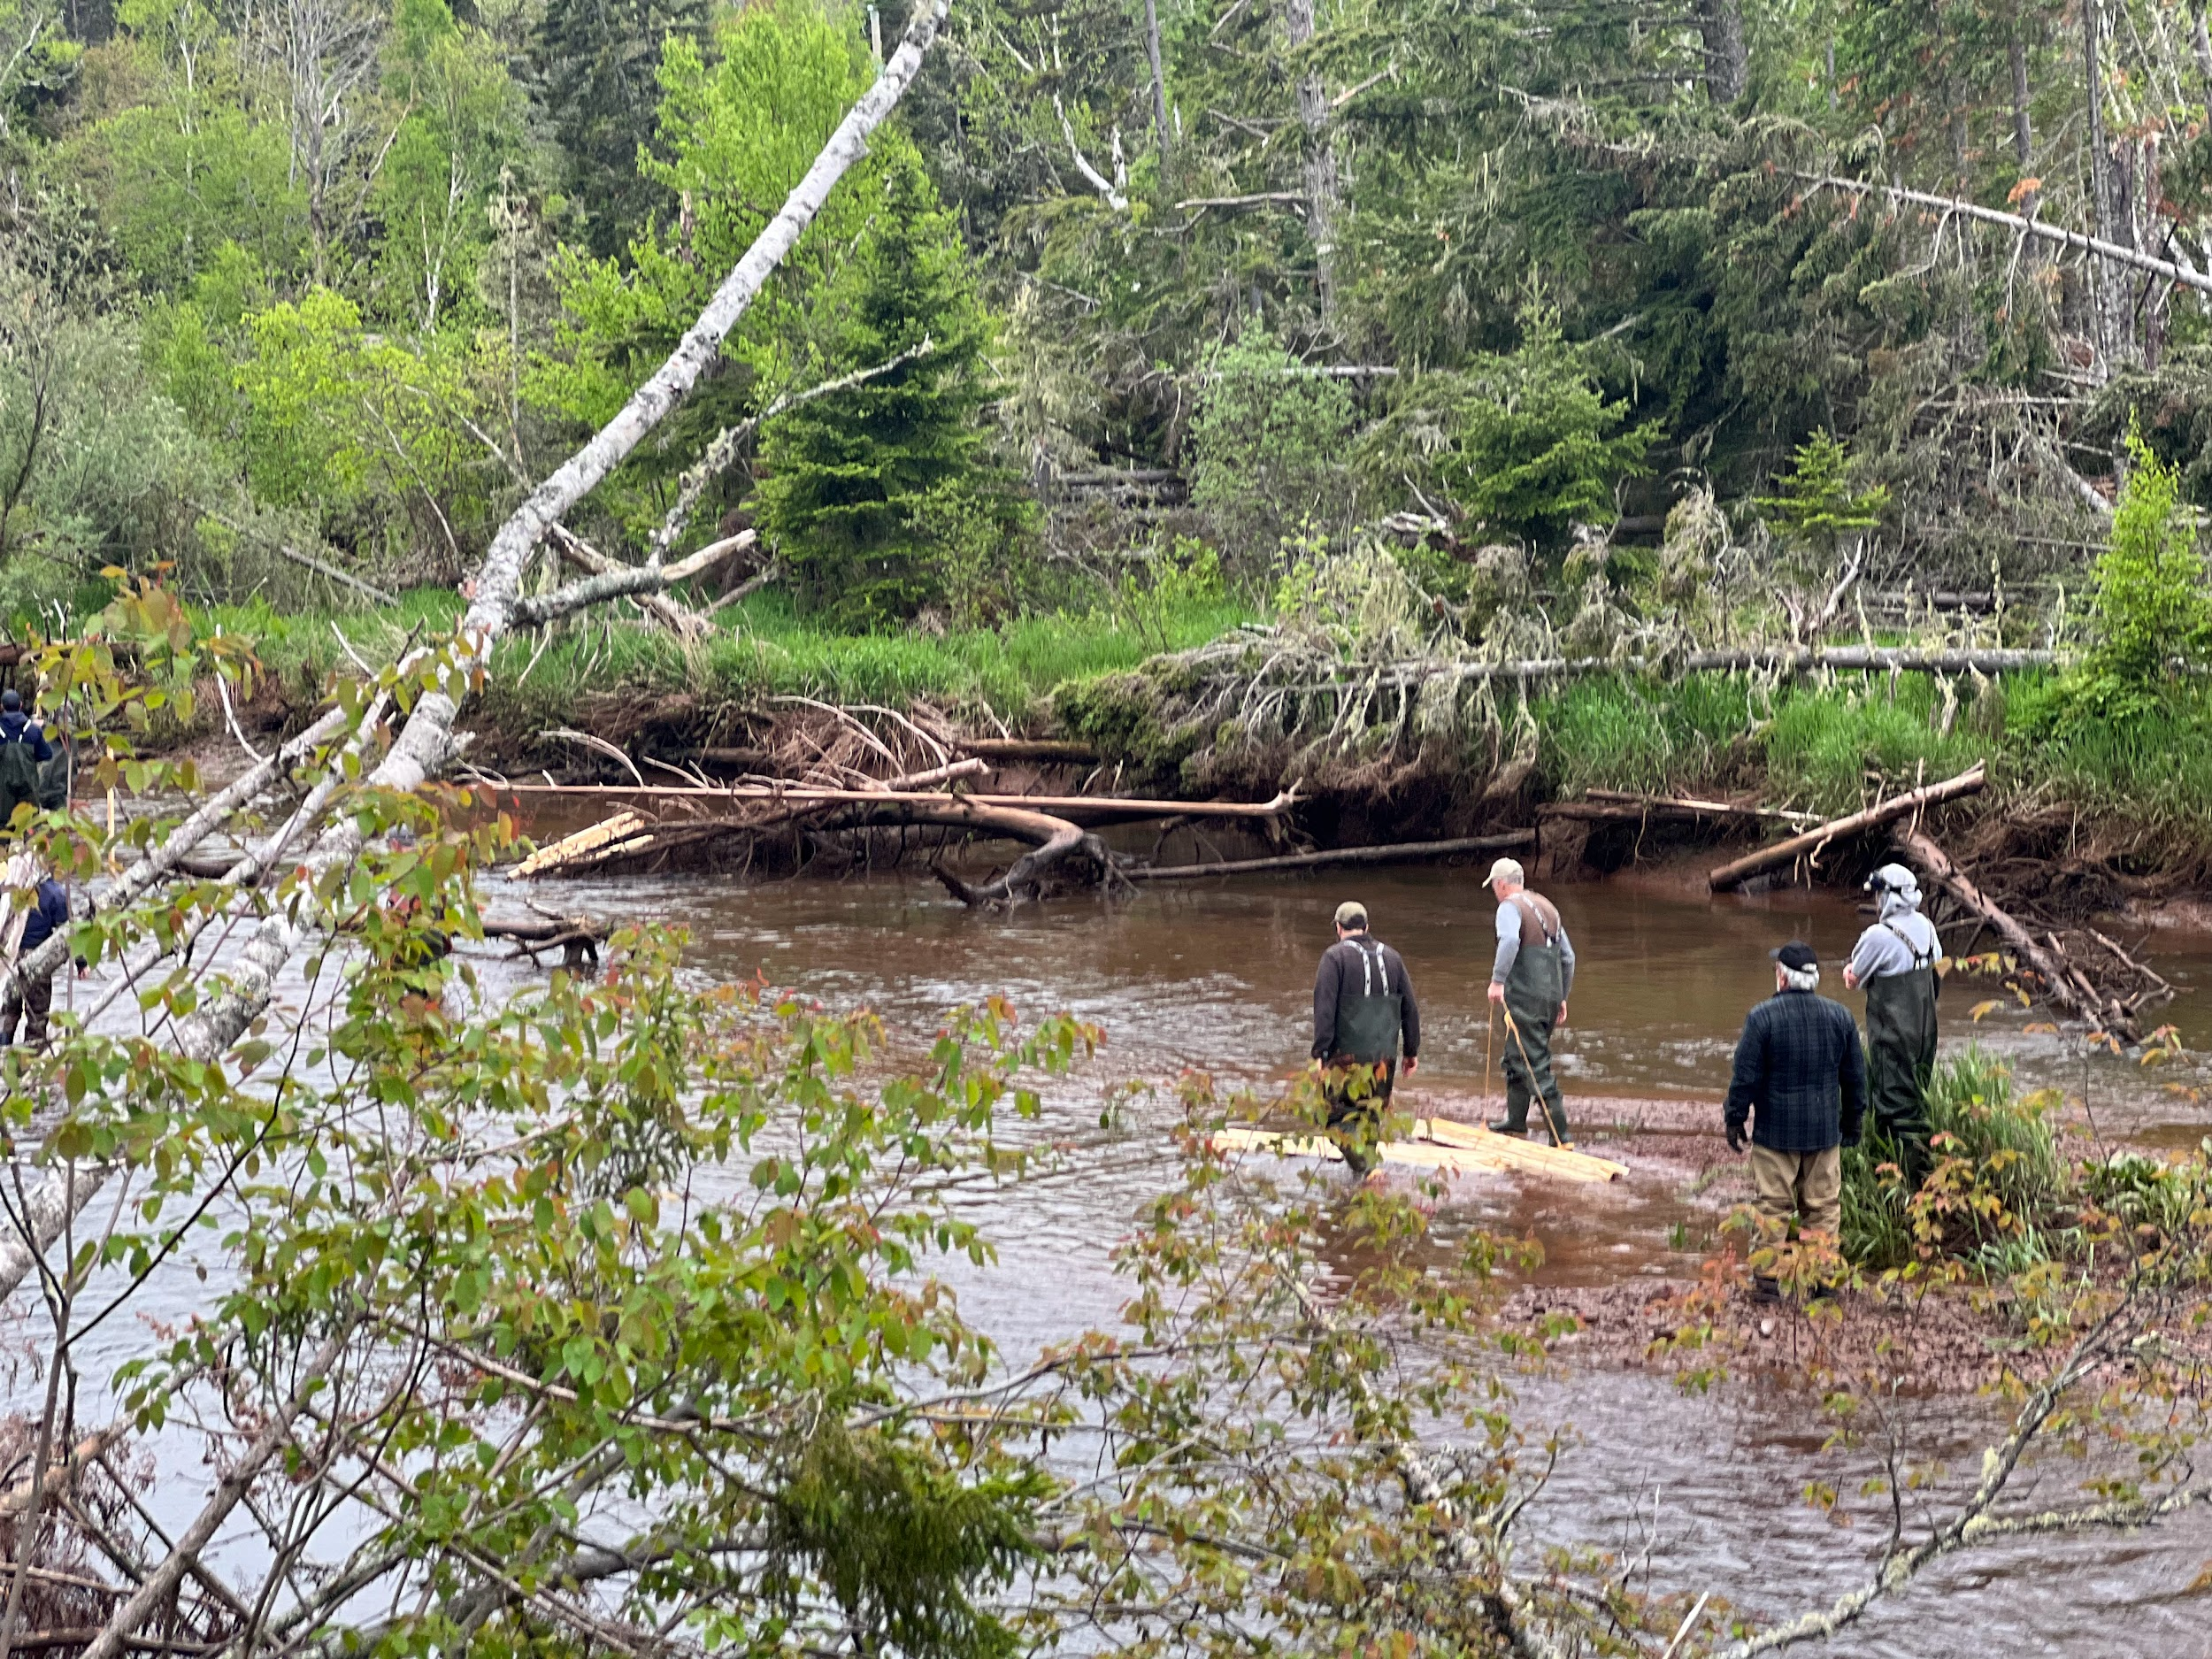
If you would like to become more involved send us an email at cqwf.pei@gmail.com to subscribe to our email list. CQWF hosted two volunteer days in the 2023 season including the creation of a new brush mat and a living shorelines project. These events are hosted on Saturday mornings and are intended to give the public a chance to get hands-on experience doing restoration activities. We hope to see some new faces at our Saturday morning volunteer days so stay tuned for those dates once we arrive closer to the summer season. Typically we have a volunteer day event on the last Saturday morning (9 am) of each month beginning in June. We are always looking for any volunteer day suggestions or ideas so please feel free to reach out with any that you may have we’d love to hear from you.
Hard working volunteers constructing a brushmat (2023 volunteer day)

Our Funding Partners
We would like to acknowledge and thank all of our volunteers and funding partners, without whose support we would be unable to continue our restoration efforts:
- The Foundation for Conservation of Atlantic Salmon
- PEI Wildlife Conservation Fund
- PEI Dept. of Transportation and Infrastructure
- PEI Dept. of Communities, Land and Environment
- PEI Dept. of Tourism
- Government of Canada

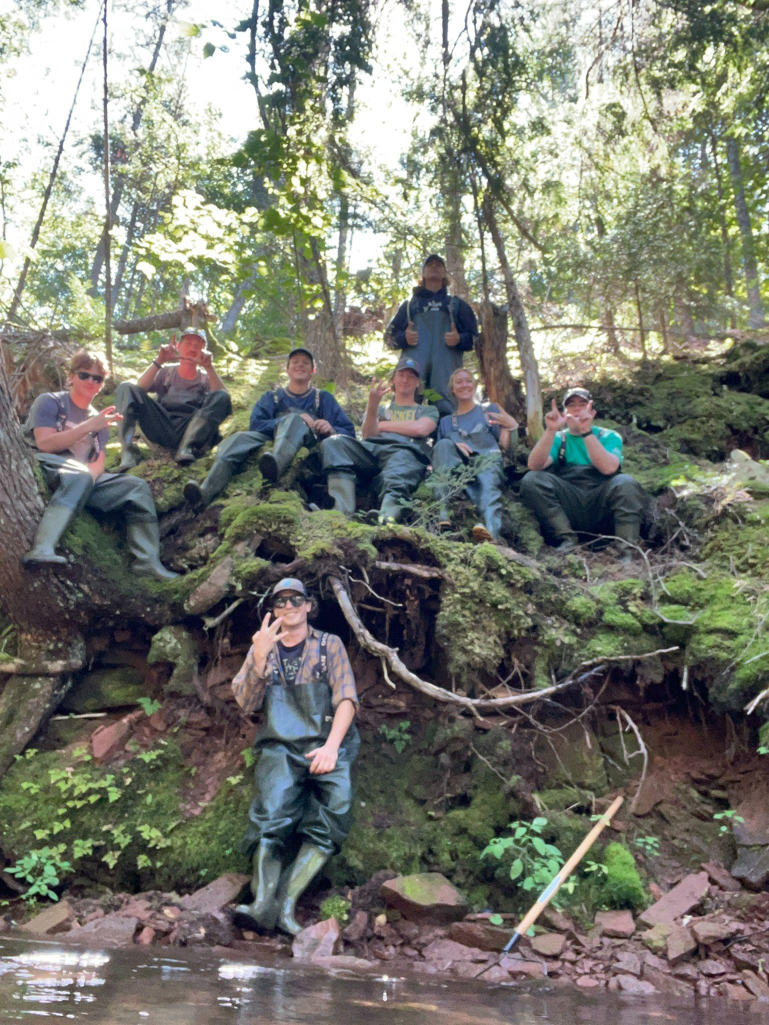

CQWF 2023 Field Crew

Stay tuned to our Facebook page or sign up for our email list to stay up to date on upcoming events in our 2024 field season.

Stay Up to Date
Website: www.centralqueenswildlife.ca
Facebook: www.facebook.com/CentralQueensWildlifeFederation
Youtube: @centralqueenswildlife549
